**Proposal-1:**

**Project Details:**

Extracting website data for use in another website

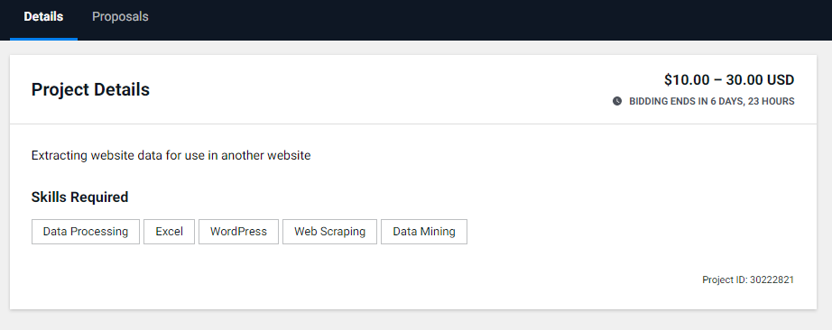

**Proposal:**

Hello There,

It's Exciting that you 're looking to do Web Scraping Tasks.

I'm Heba, a ML\NLP Engineer for +2 Years’ Experience.

I've a previous experience in Web Scraping with selenium and beautifulsoup in python, and i'll be able to deliver you any format of data you would prefer (Structured documents, Excel sheets, etc)  
I only Need One day to review the website and State the appropriate Script for the content and the output format, and another day of maybe half to let the script run in a reasonable time slots to not be blocked by the website (Expecting scraping lots of data)

I would be happy to discuss with you the project needs and how can i help you meet them.

Looking forward to talking with you.

Heba G. ElDin.

**Proposal-2:**

**Project Details:**

- Data Analysis Students: Data Cleanup **and** Regression Analysis

a. Combine the files, clean, **and** manipulate them.

b. Formulate at least 5 different questions **and** provide answers to them with at least 5 informative visualizations with your explanations **and** comments.

c. The work should be submitted **in** a .py/.ipynb/.r script.

Fixed price: $100

Project Type: One-time project

Attachment: [email-list]

(https://docs.google.com/spreadsheets/d/15knJJmR3EZxPzfvF7a1lNSLsNjt3sucDYuK9OSrfzOg/edit*#gid=0)*

**Proposal:**

Hello There,

I noticed your project and it stood out me because it’s extremely similar to what I’m working on right now.

I’m Heba, a Data Analytics Specialist with +1 Year Experience.

I’ve worked on data cleansing, wrangling, visualization and modeling in python, dealing with large datasets.

I have previous experience with regression analysis, linear and polynomial with the ability to tell story about the data trends and patterns.

I would be happy to discuss more details about the project and to show you some of my previous experiences in my repository:

<https://github.com/HebaGamalElDin?tab=repositories>

Looking forward to hearing from you.

Heba G. ElDin.